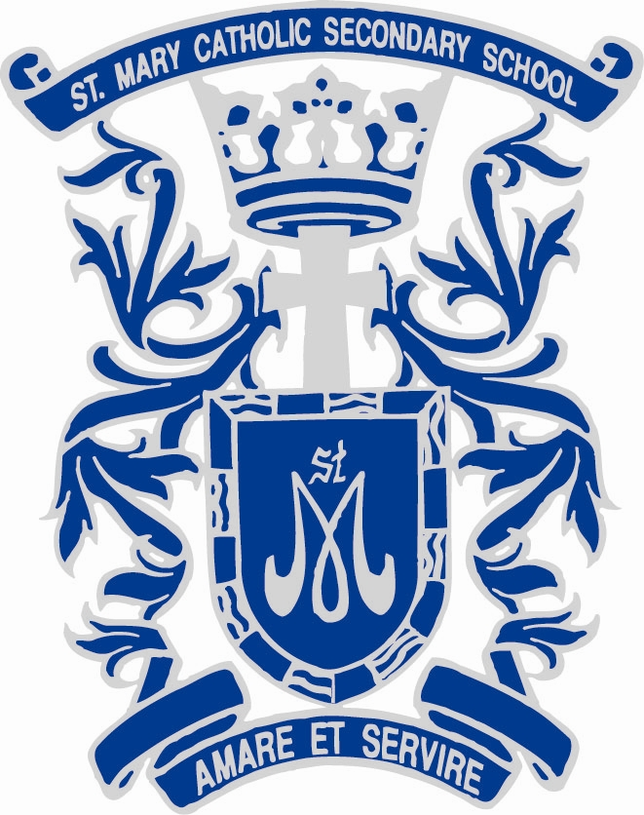
Pathways to the Future… Looking Beyond Secondary School & Community Living

COMMUNITY SUPPORTS

Community Living Ontario
www.communitylivingontario.ca
Toronto: cltoronto.ca
Oshawa/Clarington: communitylivingoc.ca
Community Living Ontario is a non-profit, provincial association started in 1953, which advocates for people who have an intellectual disability to be fully included in all aspects of community life. Community Living Ontario and the local Community Living associations are also part of the Canadian Association for Community Living.

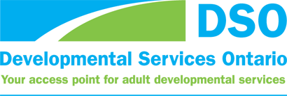
Developmental Services Ontario
www.dsontario.ca
DSO Central Region: www.yssn.ca

Developmental Services Ontario helps adults with developmental disabilities connect to services and supports in their communities. There are nine agencies across Ontario to serve you. Our organizations are funded by the Ontario Ministry of Community and Social Services.
Wherever you live in Ontario, we can help you or someone you care for to connect with available:
- residential supports
- caregiver respite
- community participation supports (i.e., recreation, volunteering, employment, in-home supports)
- professional and specialized services
- person-directed planning
- other supports to help people with developmental disabilities become more involved in their communities!

Ontario Disability Support Program
www.mcss.gov.on.ca/en/mcss/programs/social/odsp/
If you have a disability and need help with your living expenses, you may be eligible for the Ontario Disability Support Program (ODSP).
ODSP offers:
- financial assistance to help you and your family with essential living expenses
- benefits, for you and your family, including prescription drugs, dental services and vision care
- help finding and keeping a job, and advancing your career

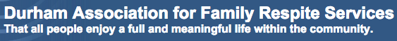
Durham Association for Family Respite Services
www.dafrs.com
DAFRS works in partnership with families with a member who has an intellectual disability or a child with a physical disability, providing Family Support (services, resources, and other types of assistance) that enhance the capacity of the whole family to care for one another and to sustain and/or enhance their valued social roles as family members and as members of the community.

Resources for Exceptional Children
www.rfecydurham.com
Resources for Exceptional Children and Youth – Durham Region will:
- Assist the family to enhance their child’s participation in the community, and support the family to advocate for services that they require.
- Work in partnership with agencies and organizations to foster an inclusive continuum of services and facilitate the community’s capacity to respond to the family’s needs.
- Deliver services in accordance with the mandate and the resources available to us.
POST-SECONDARY & ADULT EDUCATION

Durham Catholic District School Board – Archbishop Anthony Meagher Catholic Continuing Education Centre: Employment Preparation and Training
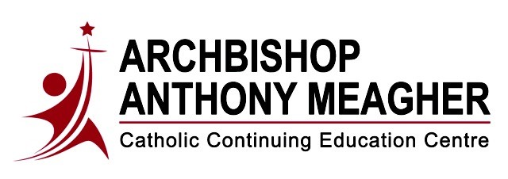
https://www.con-ed.ca/en/employment-preparation-training/employment-preparation---training.aspx
Through our employment preparation and training programs, we offer a variety of courses to meet the diverse needs of our students throughout the Durham Region. The following programs help students prepare for the workplace or post-secondary education:
- Adult Upgrading
- Child Care Assistant Training Program
- Custodial Services Training Program
- Microsoft Office Certification
- Personal Support Worker (PSW)
- PSW North Program
- Work-4-Credits (Cooperative Education)

Durham College: Community Integration Through Cooperative Education (CICE)
www.durhamcollege.ca/programs/community-integration-through-cooperative-education
Community Integration through Cooperative Education (CICE) gives individuals with intellectual disabilities or significant learning challenges the opportunity to enhance their academic and vocational skills with modified programming through a variety of courses. The program includes a number of core courses common to all CICE students in topics such as interpersonal communication, job skills, self-advocacy, self-awareness and computer skills. Other courses are drawn from a variety of Durham College programs, and may not come from one specific program area, but a variety of programs related to a vocational field of interest.

George Brown: College Vocational Program
https://www.georgebrown.ca/programs/college-vocational-program-a101
The College Vocational program provides vocational assessment, upgrading in communications, math, and computers; life skills, career planning and a work experience placement for students with mild- to- moderate intellectual disabilities.

EMPLOYMENT

Community Living (Oshawa): Employment Services
communitylivingoc.ca/services/adults/employment-services
Community Living (Toronto): Employment Services
cltoronto.ca/supports-and-services/job-placement-services

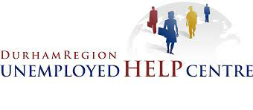
Durham Region Unemployed Help Centre
http://www.unemployedhelp.on.ca/

Northern Lights Canada (Oshawa)
www.northernlightscanada.ca

Ontario Works
www.mcss.gov.on.ca/en/MCSS/programs/social/ow/index.aspx

RECREATION/DAY PROGRAMS

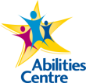
Abilities Centre
www.abilitiescentre.org
A charitable organization that delivers enriching sports and fitness, arts, research and education, and life skills opportunities for people of all ages and abilities.

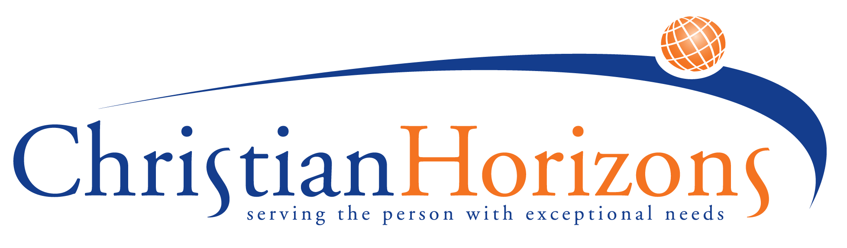
Christian Horizons
www.christian-horizons.org
Christian Horizons empowers individuals with exceptional needs, enabling them to embrace their God-given potential and enjoy hope and opportunity in everyday living. We believe everyone has a unique purpose and unique gifts to share and we help exceptional individuals make the most of their abilities. We strive to create a fulfilling and meaningful life for the people we serve and offer a warm environment of friendship and support.

Grandview Children’s Centre
grandviewkids.ca
Grandview Children’s Centre is an independently operated not-for-profit organization. We are the only children's treatment centre in Durham Region providing specialized programs, outpatient clinical treatment, and support to thousands of children and youth with special needs and their families.

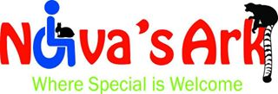
Nova’s Ark
www.novasark.ca
Nova’s Ark is committed to building acceptance of people of all ages and abilities by providing opportunities for understanding through a wide range of activities and programs involving unique and gentle therapy animals.

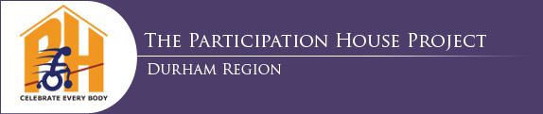
Participation House - Durham
www.phdurham.com
The Participation House Project (Durham Region) is a non-profit organization developing and providing a range of services for youth and adults with physical and developmental disabilities throughout Durham Region. Chartered in 1975, the organization is directed by a volunteer community-based Board of Directors committed to the belief that people with disabilities are entitled to shape their lives and actualize their potential.

Special Olympics Ontario: Greater Durham
greaterdurham.specialolympicsontario.ca
Special Olympics Ontario is a volunteer driven organization with some 18,000 athletes and 9,000 volunteers registered across the province. Athletes range in age from 2 - 80 and have the opportunity to train in 18 core sports. The Greater Durham Community of Special Olympics Ontario has more than 300 registered athletes and over 100 volunteers committed to the growth of our athletes. Every facet of our community is dedicated to enriching the lives of people with intellectual disabilities.

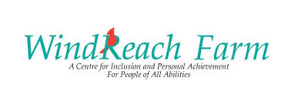
Windreach Farm
www.windreachfarm.org
Our unique facility dedicated to enriching the quality of life for people of all ages and abilities is a testament to Sandy’s determination to help people live lives to their fullest.
Since 1989, WindReach Farm has been empowering, inspiring, and changing lives. By making inclusion a core value, we remove barriers of any kind.
Located in the Durham Region, this beautiful 105 acres of farm host a variety of educational, therapeutic and recreational services. Through the use of our fully accessible facility, we provide opportunities that can become extraordinary gifts.
ADDITIONAL SUPPORT RESOURCES

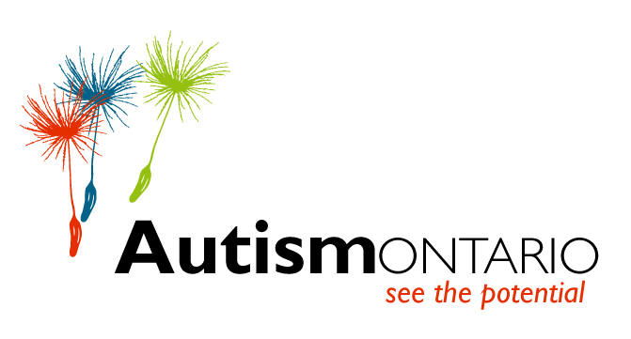
Autism Ontario
www.autismontario.com
Our Vision: Acceptance and opportunities for all individuals with Autism Spectrum Disorders.
Our Mission: To ensure that each individual with ASD is provided the means to achieve quality of life as a respected member of society.

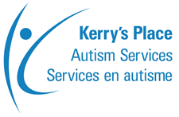
Kerry’s Place
www.kerrysplace.org
Kerry's Place Autism Services has been committed to enhancing the quality of life of persons with Autism Spectrum Disorder (ASD) since 1974 by being leaders in developing and providing evidence-based supports; and by building capacity by sharing our knowledge. We are Canada's largest service provider for children, youth and adults with ASD and serve more than 8,000 people with ASD and their families each year.

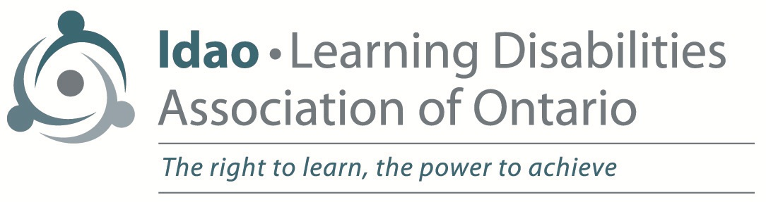
Learning Disabilities of Ontario
www.ldao.ca
Learning Disabilities of Durham Region
www.ldadr.on.ca
The Learning Disabilities Association of Ontario is a registered charity dedicated to improving the lives of children, youth and adults with learning disabilities. Our mission is to provide leadership in learning disabilities advocacy, research, education and services and to advance the full participation of children, youth and adults with learning disabilities in today’s society.

National Education Association of Disabled Students (NEADS)
The Association effectively delivers a number of core programs. Our primary activities include: maintaining a comprehensive, unique Web site www.neads.ca and financial aid portal www.disabilityawards.ca; developing skill training resources relevant to students with disabilities in post-secondary education and employment; conducting relevant research on access to post-secondary education and employment opportunities; and, holding regular regional events across Canada to provide resources and skill development to students with disabilities. The website houses numerous online resources and publications that are unique to NEADS and were developed by the organization.

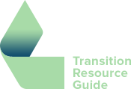
Transition Resource Guide – Resource Guide for Students with Disabilities: Transition to Post-Secondary
www.transitionresourceguide.ca
This guide has been created by the Regional Assessment and Resource Centre (RARC). RARC provides accurate and comprehensive assessments and follow-up services to post-secondary students with Learning Disabilities, ADHD, and ASD. This guide is a way for students with disabilities to arm themselves with knowledge they need to access resources at college and university and to make a successful transition from secondary to post-secondary school.

