- Go to stmary.dcdsb.ca > Students > Launchpad Learning Portal Log In link. This will open a log in screen.

- Log in with your school email and password.
Ex: 123456789@dclive.ca

- Click on the myBlueprint icon.

- To view a video demonstration on how to select your courses copy the link below into your browser or view the student video directly from your myBlueprint account. https://myblueprint.ca/support/videos/course-selection/4DWTLIEMhGmo4wIqQasS6g

- Once you’ve clicked on the myBlueprint icon, you must click on the green School Account Log in button

- To enter your course selection for next year, select High School from the list of options on the left side of the screen.

- Your next school year will be highlighted. You can change your selections as many times as you like until you select the Submit button.

- To select a compulsory course, click on subject (English, Math, etc) in the course box. All of the course options for that subject will appear. If you click on the course name, the course description will appear. To select the course, click on the Add Course button. You will then return to the High School Plan Grid. You may also consider narrowing your search by selecting the Grade in the Filter section (ie., Grade 9) and only the courses in that subject and grade will appear.

- In Grade 9, the following 7 courses are compulsory: Religion, English, Math, Science, Geography, Phys Ed, and French. French Immersion students are required to take the courses in bold in French. The 6th digit in the code is F. Students in French Immersion must choose FIF1DF.

- Continue to add until you have selected all your compulsory courses.
- When selecting Phys. Ed, please pay attention to the 6th character in the course code:
F = female (French Immersion)
G = male (French Immersion)
3 = female
4 = male
*PAF1O3 = female yoga/pilates
- If you choose a course in error, click on the right side of the course and select Edit, Change or Delete.

To choose an elective course click on Course located within the course box.
- In Grade 9, students will select 1 elective course,
- From the Filters section select Grade and choose Grade 9

- Options can be found under Arts, Business and Technology
- If you choose a course in error, click on the right side of the course and select Edit, Change or Delete

All students must ALSO select one alternate course. In case an elective course does not fit in your schedule for next year, your alternate course will be used without notice. Steps for choosing alternates are the same as those for choosing electives. Review the process and repeat.

- A Blue Box indicates an Advisor note. Hold the mouse over the blue symbol and the note will appear. A Red Box indicates that there’s a course restriction. Hold the mouse over the red symbol and the restriction will appear.

- Once all courses and alternatives have been selected, click Review Course Selections button. Check to ensure that you have the proper pre-requisites and have met the recommended grade for certain courses.

- Review your course selections. If you are satisfied with your choices, click Submit Course Selections button.

- Once you’ve submitted your courses, you must send your parent/guardian an email so that they can electronically approve your selections. Click Send Approval Email and follow the prompts.
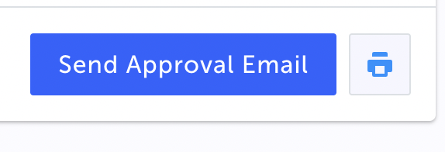

- Print a copy of your Course Selection form to be submitted to your Grade 8 teacher. To print a copy, click Printer icon button
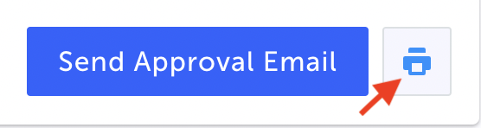
- Please ensure that you have read the policy regarding Course Options Changes. There will be NO discretionary changes.

- Once this course sign-off sheet is approved by your parent, it will be considered successfully submitted.
The course selection form with parent approval must be completed by Thursday, February 9, 2023 with the Student Activity Fees* of $75.00 paid using EXACT CASH or through School Cash Online.

*Student Activity Fees are used to defray the cost of:

- Yearbooks
- Student Retreats
- Clubs
- Honorariums for guest speakers
- School Council Activities
- Dudley Lock

