**ST. MARY C.S.S. PARENT COUNCIL**

**Tuesday May 6th, 2025**

|  |  |  |
| --- | --- | --- |
| **Executive Members** | **Name** | **Sign In** |
| Principal | John Di Vizio | P |
| Chair | Adele Sartor | P |
| Co-Chair | Sabrina Pallotta | R |
| Secretary | Paul Dalton | P |
| Financial Secretary | Emily Povolo | P |
| Teacher Representative | Melissa Wilson-Clark | R |
| Chaplain | Mariana Bosetti | P |
| Parish/Non-Teaching Representative | Danilo Simonelli (SIJ) | P |
| **Parent Representatives** | | |
| Parent Representative | Amanda Dass | R |
| Parent Representative | Arianna D’Urso | R |
| Parent Representative | Ayesha Sardar | Ab |
| Parent Representative | Babz Boehm | R |
| Parent Representative | Barbara Perrott | P |
| Parent Representative | Bessy Stergiou | Ab |
| Parent Representative | Carla Hipolito | Ab |
| Parent Representative | Claudia Nicholas | R |
| Parent Representative | Cordelia Clark Julien | Ab |
| Parent Representative | Danielle Boyle | P |
| Parent Representative | Jason Boyle | P |
| Parent Representative | Jennifer Millar | P |
| Parent Representative | Kim Layman | R |
| Parent Representative | Leah Changoo | P |
| Parent Representative | Lilani Kulathungam | Ab |
| Parent Representative | Mark V. Campbell | Ab |
| Parent Representative | Melissa Edwards | Ab |
| Parent Representative | Melodie McLymont | Ab |
| Parent Representative | Nancy Barry | P |
| Parent Representative | Nicola Sutton-Leslie | P |
| Parent Representative | Nindu Kumar | P |
| Parent Representative | Oluwoyomi Dime | P |
| Parent Representative | Paula Thomas | P |
| Parent Representative | Rachel Vigliatore | P |
| Parent Representative | Reg Sadler | P |
| Parent Representative | Shivaun McLymont | Ab |
| Parent Representative | Tara King | Ab |
| Parent Representative | Tonia Edwards Kelegan | P |
| Parent Representative | Zhora Adatia-McGlashen | P |

**Attendance:** P= PresentAb = Absent R = Regrets

**Other Attendees:** Jayson Julien, Alison Pierre

|  |  |  |
| --- | --- | --- |
|  | |  |
| **CALL TO ORDER** | | |

**Meeting Called to Order**: 7 pm

**Welcome**: A. Sartor

**Opening Prayer**: Mariana Bosetti

|  |
| --- |
| **ACTIONS TO BE TAKEN** |

**Approval of Minutes**: April 1st, 2025 - A. Sartor

**Motion to Approve by:** R. Sadler **Seconded by:** D. Simonelli

|  |
| --- |
| **REPORTS / INFORMATION ITEMS** |

**Grad Gift Update:** Kathleen McAdam

Mrs. McAdam attended and presented the Science Department’s wish list to be considered for the Grad Gift for 2025. There are a few big-ticket items that the department needs over the next few years, but when asked if there was a priority based on the list provided, she suggested new periodic tables (periodic tables currently in use are dated, from 1988. Do not even contain new elements discovered since then.). It was suggested that these would make a good grad gift, as they would be used by every single science class within the school.

The list of items that were presented are the following:

* **Large Periodic Table Wall Chart** (to replace the 1988 versions missing 30 elements in our classes): Useful for all of the science classes within the school.
* **10-mL Pipette Pumps** (to replace cracked bulbs and older lab tech): Useful for grade 11-12 chemistry, 12 biology.
* **Anatomical Torso Model** (ours was stolen/went missing 10+ years ago): Useful for grade 9-12 biology.
* **Molecular Model Kits** (to replace incredibly old spring/wood block kits): Useful for grade 9-12 chemistry.
* **Electric Circuit Kit** (To replace many older, broken kits): Useful for grade 9, 11-12 physics.
* **Microscopes – HM Series (Boreal)** So that there is a 2:1 student: microscope ratio in courses vs 3:1): Useful for grade 9-12 biology.

The Parent Council voted on the options and will use the Grad Gift funds ($2,000) to put towards the Large Periodic Table Wall Charts.

**Next Year’s Parent Council Meeting Dates:** Adele Sartor

We reviewed the dates for Parent Council Meeting dates for 2025/2026 school year. These meetings are typically the first Tuesday of each month, and there is not a meeting in December or March because of Christmas and March Break respectively.

The approved dates for the 2025/2026 school year are as follows:

* September 16th (Elections)
* October 7th
* November 4th
* December 2nd
* February 3rd
* April 7th
* May 5th
* June 2nd

**St. Monica Unveiling:** Paul Dalton

In 2021, Parent Council members at St. Monica’s Catholic Elementary School joined the DCDSB Anti-Black Racism Committee, leading to the recognition that the image of St. Monica was inaccurate. In response, the school, led by Principal Mr. Szent-Ivany in partnership with Parent Council, launched Anti-Black Racism Community Consultations in December 2022. These involved broad community participation and support from DCDSB Superintendents and Trustee Jim McCafferty.

One major outcome was the recommendation to reimagine the image of St. Monica. After a lengthy search, **a Grade 10 student from St. Mary, Tarie**, took on the task. She conducted extensive research to create an accurate and respectful depiction of the Saint. The new image was officially unveiled at St. Monica earlier today in a special mass and ceremony.

This project represents a meaningful collaboration between St. Monica and St. Mary and highlights our community’s commitment to equity, inclusion, and student belonging.

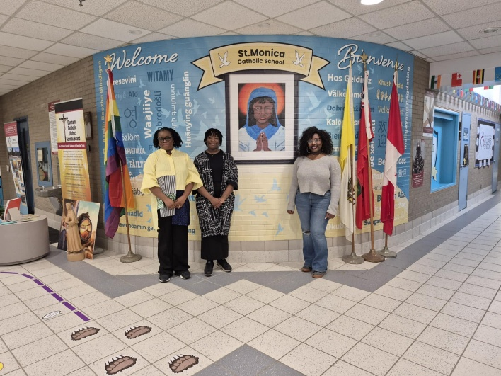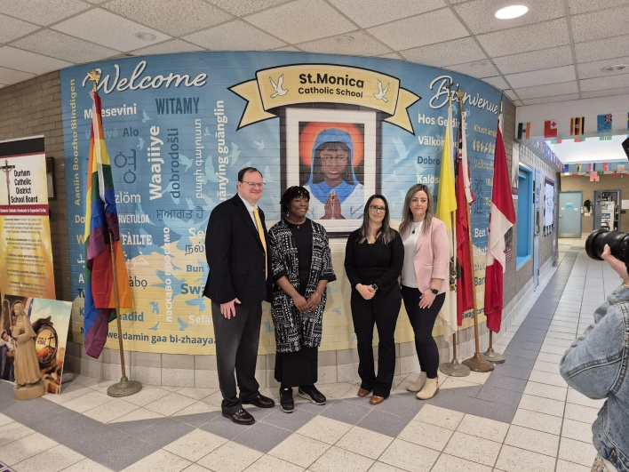

**Financial Update:** Emily Povolo

Parent Council were tasked to make 2 decisions for financial support, including the 2025 Grad Gift Funds and the Bursaries and scholarships for the 2025 Graduation Class.

* The Parent Council will use the Grad Gift funds ($2,000) to put towards the Large Periodic Table Wall Charts.
* The Parent Council will fund $2,000 towards scholarships and bursaries for the 2025 Gradation class. The breakdown is as follows:
  + Bursaries “Amare & Servire”: 8 x $200 ($1,600)
  + Allyship: $200
  + Jade DeCastro: $200

Note, there are 320 graduating students this year.

**Uniform Sale:** Adele Sartor

The Parent Council is happy to announce that we will be hosting the used uniform sale again this year. Given the timing of Canada Day, we will hold the sale on Tuesday July 8th. We will get donations as we have in previous years (encouraging graduating students to donate their used uniforms and be allowed to take their exams in civies). We will be looking for both student and parent volunteers. More information to come closer to the date.

**Parish Update:** Danilo Simonelli

* N/A

**Principal’s Report:** John Di Vizio

School Evacuation:

There was an evacuation on Holy Thursday. There were students that set fires in 2 separate bathrooms, and police and school are taking appropriate action given the severity of the situation.

That said, the safety and wellbeing of our school community is our first priority. VP extinguished the flames. Students and staff were evacuated in a safe and timely manner. The Firefighters arrived and brought fans to ensure the smoke within the school was cleared.

Parent Email:

Mr. Di Vizio responded to an email that was sent to the full Parent council with regards to concerns from a parent that covered a few topics. Given these are concerns from a parent to the school that are more of a personal issue, John will connect and resolve this with the parent outside of the council. Parent council is an advisory council.

We reviewed the process if there are concerns that need to be addressed, either academically or otherwise, the first step is to communicate with the teacher. If, for some reason, there is no response or if you feel more can be done, the next step is to escalate to the appropriate VP. From there, if the situation has still not been resolved, the Principal will get involved.

Based on the discussion with the council, we are looking to put the information from Grade 8 Orientation Night on the website. It is a great summary of resources, especially if they were not able to attend the orientation or are new to the school.

Future Graduation Locations:

The school is looking at potential new locations for graduation starting next school year given our school’s growing population over the next few years, and the increase of cost for the current location in Oshawa.

The administration has looked at many locations and is considering The Arena at Pickering Casino Resort. A formal vote was not done, but rather an inquiry over any concerns about the location. During the discussion, the new Durham Convention Centre was mentioned. It is unknown whether it is also in consideration for future use so the administration will take that away and investigate further.

**Key Dates**

**May 5th – 9th Catholic Education Week**

May 5th Skills Ontario Competition

Baseball

Durham College Visit

May 6th Skills Ontario Competition

Jr Girls Soccer

Monarch Day

May 7th Mass (Archbishop Visit Cancelled)

May 8th Grade 9 Retreat

Jr. Girls Soccer

STEM Principals Teal - Parkwood

TAMI Conference

May 9th Baseball

Jr. Girst Soccer

Seton Track & Field Date

Sr. Badminton

May 12th Baseball

Grad 9 Retreat

Jr. Girls Soccer

White Pines

Grade 9 Homeroom Cannabis Presentation

May 13th Jr Girls Soccer

Outdoor Education Trip

Prom Assembly

May 14th Roadtrip

STEM Principles Tea – Parkwood

Grade 9 Homeroom Cannabis Presentation

May 15th Baseball

Band Concert

May 16th Jr & Sr. Badminton

**May 19th Victoria Day**

May 20th Baseball

Jr. Girls Soccer

Sick Kids Day

Wonderland Trip

May 21st Non-Uniform Day

Pickering Library in the Atrium*

May 22nd Bring a Plushie Day

Jr. Girls Soccer

University Panel for Grad 11’s

Spring Vocal Concert

May 23rd Baseball

Retreat Leader Training

Cops vs. Students Game

May 26th Career Coaches

May 27th Jr. Girls Soccer

Miller Waste System

Career Coaches (Grade 10’s)

**May 28th Prom**

St. Monica Track & Field

Outdoor Education Planting

May 29th Jr. & Sr. Badminton

May 30th Ontario Tech Trip

Jun 2nd OFSAA Tennis

Jun 3rd OFSAA Tennis

BLOSM Year End Trip

Landmark Cinema Film Trip

Jun 4th OFSAA Tennis

Trip Moratorium

Closing Mass

Jun 5th DECCA Track & Field

Dance Showcase

Jun 6th Grad Breakfast

Jun 9th FOS Track & Field

BLOSM Celebration

Jun 11th Grade 9 EQAO

ArtsFest

Jun 12th Athletics Banquet

**Jun 17th**  **Grade 12 period 4 Exam**

**Jun 18th – 22nd Exams**

Jun 20th St. Isaac’s Graduation

Jun 23rd St. Monica Graduation

**Jun 25th Graduation**

**Jun 27th Report Cards**

*Pickering Public Library will have a booth set up for upcoming events and what they can offer students over the summer.

|  |
| --- |
| **OTHER ITEMS** |

* Donations to the School: Earphones – Half of the earphones that are being donated were delivered last week. The remaining earphones are coming soon.
* Paving for walkway to outdoor learning space will begin soon.

|  |
| --- |
| **ADJOURNMENT** |

**Closing Prayer: Mariana Bosetti**

**Meeting Adjourned**: 9:25 PM

Next St. Mary CSS Council Meeting

Tuesday June 3rd @ 7:00 pm – St. Mary Learning Commons

*St. Mary CSS Parent Council meetings usually take place on the first Tuesday of the month, from 7:00pm – 8:00pm in the school library. All parents are welcome to attend the monthly Parent Council meetings and bring agenda items forward for discussion.*